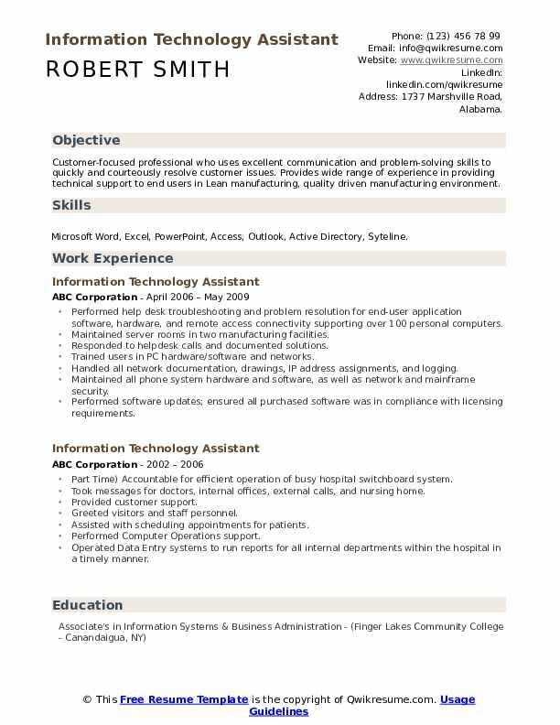
Information Technology Assistant
ROBERT SMITH
Phone: (123) 456 78 99 Email: Info@qwikresume.com Website: www.qwikresume.com
Linkedin:
linkedin.com/qwikresume
Address: 1737 Marshville Road, Alabama.
Objective
Customer-focused professional who uses excellent communication and problem-solving skills to quickly and courteously resolve customer issues. Provides wide range of experience in providing technical support to end users in Lean manufacturing, quality driven manufacturing environment.
Skills
Microsoft Word, Excel, PowerPoint, Access, Outlook, Active Directory, Syteline.
Work Experience
Information Technology Assistant
ABC Corporation - April 2006 - May 2009
• Performed help desk troubleshooting and problem resolution for end-user application
software, hardware, and remote access connectivity supporting over 100 personal computers. • Maintained server rooms in two manufacturing facilities.
• Responded to help desk calls and documented solutions.
.
Trained users in PC hardware/software and networks.
Handled all network documentation, drawings, IP address assignments, and logging. Maintained all phone system hardware and software, as well as network and mainframe security.
• Performed software updates; ensured all purchased software was in compliance with licensing requirements.
Information Technology Assistant
ABC Corporation - 2002 - 2006
•Part Time) Accountable for efficient operation of busy hospital switchboard system. ⚫Took messages for doctors, internal offices, external calls, and nursing home.
Provided customer support.
⚫ Greeted visitors and staff personnel.
"
Assisted with scheduling appointments for patients.
• Performed Computer Operations support.
Operated Data Entry systems to run reports for all internal departments within the hospital in a timely manner.
Education
Associate's in Information Systems & Business Administration - (Finger Lakes Community College - Canandaigua, NY)
© This Free Resume Template is the copyright of Qwikresume.com. Usage
Guidelines

